**Assignment 04: Assignment and practice of SORA**

# **Research & Summarize on sora :**

Sora is a cutting-edge AI model developed by OpenAI that generates high-quality videos from simple text prompts. Announced in early 2024, Sora is capable of producing realistic and coherent video clips up to 60 seconds long, complete with detailed environments, consistent characters, dynamic motion, and complex interactions. Unlike previous models focused on single-frame image generation, Sora introduces a temporal understanding of scenes, allowing it to simulate real-world physics, object permanence, and cinematic effects such as smooth camera movements or transitions. It is designed to assist content creators, educators, advertisers, and filmmakers in visualizing their ideas without traditional video production tools.

## **Comparison with DALL·E, Pika Labs, and Runway ML :**

While Sora is a leap forward in video generation, it builds upon concepts introduced by earlier AI models.

* **DALL·E (OpenAI)** focuses on generating images from text prompts. It excels at still-image creativity, including tasks like inpainting and outpainting. However, it lacks the ability to handle motion or temporal coherence. Sora, by contrast, introduces time as a core element, allowing for video sequences instead of static images.
* **Pika Labs** offers an accessible text-to-video platform, often used for stylized, animated, or short-form content. It is particularly popular for creative, artistic outputs but generally lacks the photorealism and narrative depth that Sora provides.
* **Runway ML (Gen-2)** is one of the most prominent text-to-video competitors, allowing users to create videos from text, images, or video inputs. While Gen-2 provides impressive results and real-time editing tools, Sora appears to surpass it in terms of video length, realism, and contextual consistency across frames.

## **Ethical Considerations in Video Generation :**

As AI-generated video becomes more realistic and accessible, ethical concerns grow significantly:

1. **Deepfakes and Misinformation:** AI tools like Sora could be misused to create fake videos that mimic real people, potentially spreading false information or impersonating public figures.
2. **Consent and Identity:** Using someone’s likeness—whether a celebrity or private individual—without permission poses legal and ethical risks, especially in harmful or misleading contexts.
3. **Copyright and Fair Use:** Training data and generated outputs may overlap with copyrighted content, raising issues around intellectual property and fair usage.
4. **Bias and Stereotyping:** If the model is trained on biased or unbalanced datasets, it may unintentionally reinforce stereotypes, exclusion, or cultural insensitivity.
5. **Content Moderation:** Preventing the generation of violent, explicit, or otherwise harmful videos is crucial. Developers must enforce strict guidelines and monitoring systems to ensure safe use.

In conclusion, while Sora represents a major innovation in AI-powered video creation, its use must be accompanied by ethical responsibility, transparent policies, and strong safeguards to avoid misuse.

# **Prompt Engineering Practice :**

Here are **5 creative prompts** for the following:

1. **Education (History):** *"A 15-second animated reenactment of the signing of the Declaration of Independence in 1776, with historical figures in colonial attire, candle-lit room, and parchment being signed at a wooden table."*
2. **Entertainment (Fantasy):** *"A 20-second cinematic clip of a dragon flying over a medieval castle at sunset, with glowing lava flowing from a nearby volcano and villagers watching in awe."*
3. **Environment (Climate Change):** *"A 10-second time-lapse showing a glacier melting rapidly over decades, transitioning from a frozen landscape to a dry, cracked terrain with dying vegetation and exposed rock."*
4. **Technology (Future City):** *"A 15-second futuristic cityscape at night, with flying cars zooming between neon-lit skyscrapers, robots walking on sidewalks, and holographic advertisements glowing in the sky."*
5. **Social Awareness (Inclusion):** *"A 10-second clip of children from diverse backgrounds playing together in a park, including a child using a wheelchair, with happy expressions, colorful playground equipment, and a rainbow in the background."*

# **Design a 15-second SORA video explaining one of the following:**

# **Climate Change:**

Prompt provided by me to sora :

**[0-2s]**

* **Visual:** Animated spinning Earth with light clouds.
* **Text:** "What is Climate Change?"
* **Audio:** Friendly narrator says, "What is climate change?" + soft whoosh sound.

**Image creation by sora:**

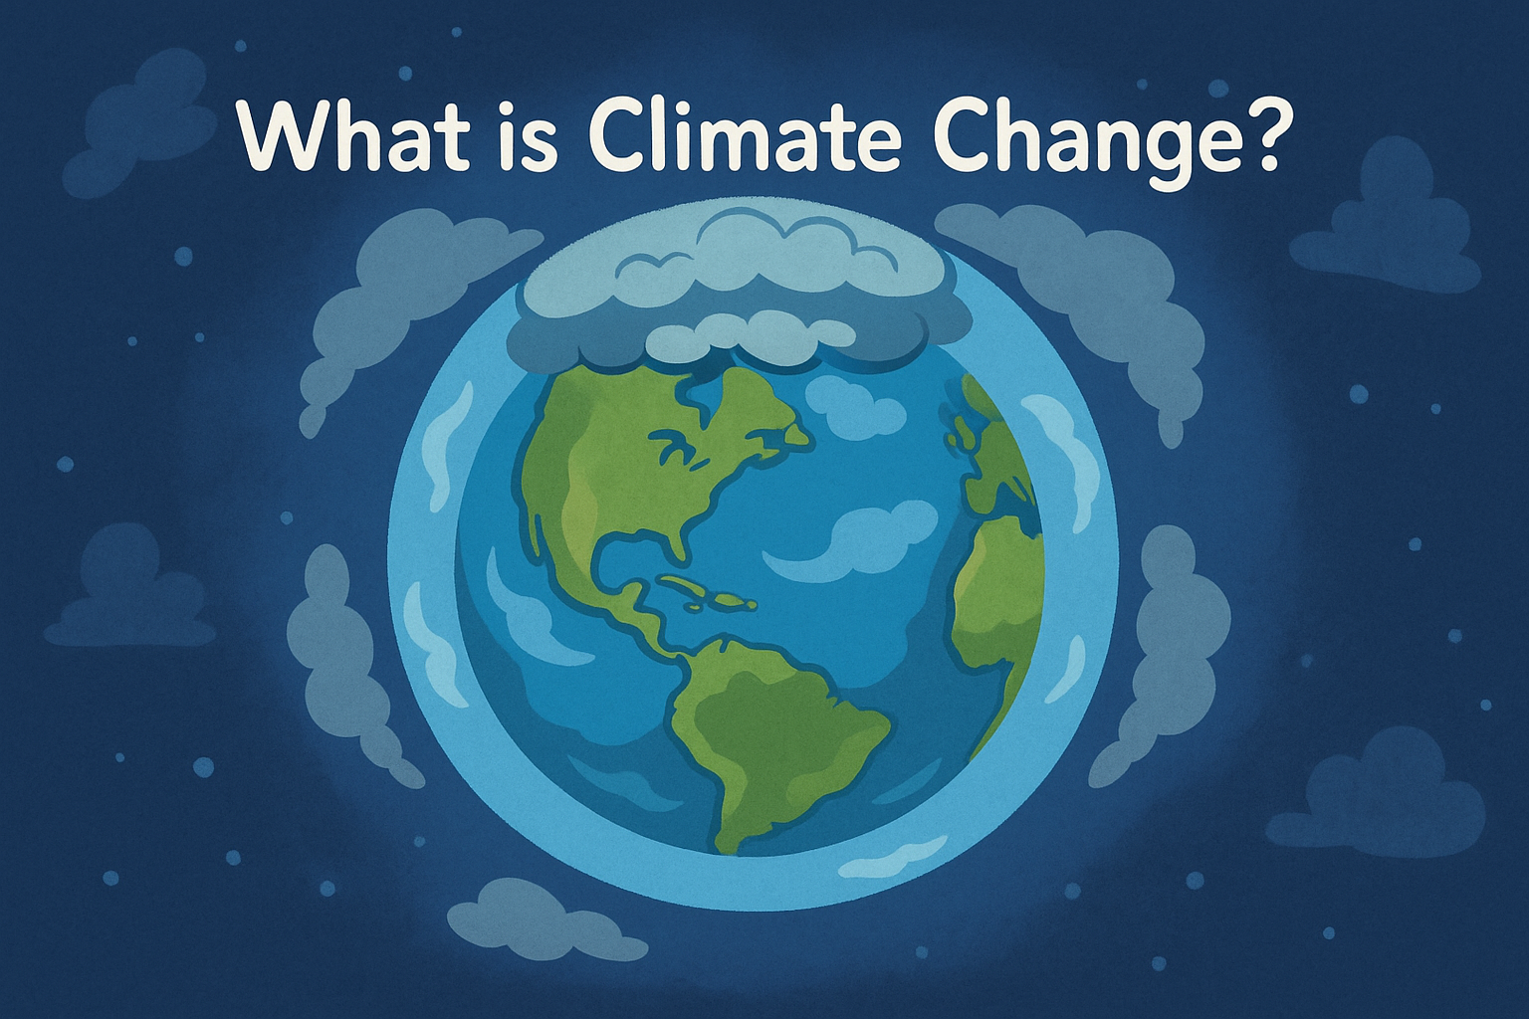

**[2-6s]**

* **Visual:** Factories and cars emit smoke, which rises and forms a grey cloud.
* **Text:** "Greenhouse gases from burning fossil fuels"
* **Audio:** Narrator: "Burning fossil fuels releases greenhouse gases."

**Image creation by sora:**

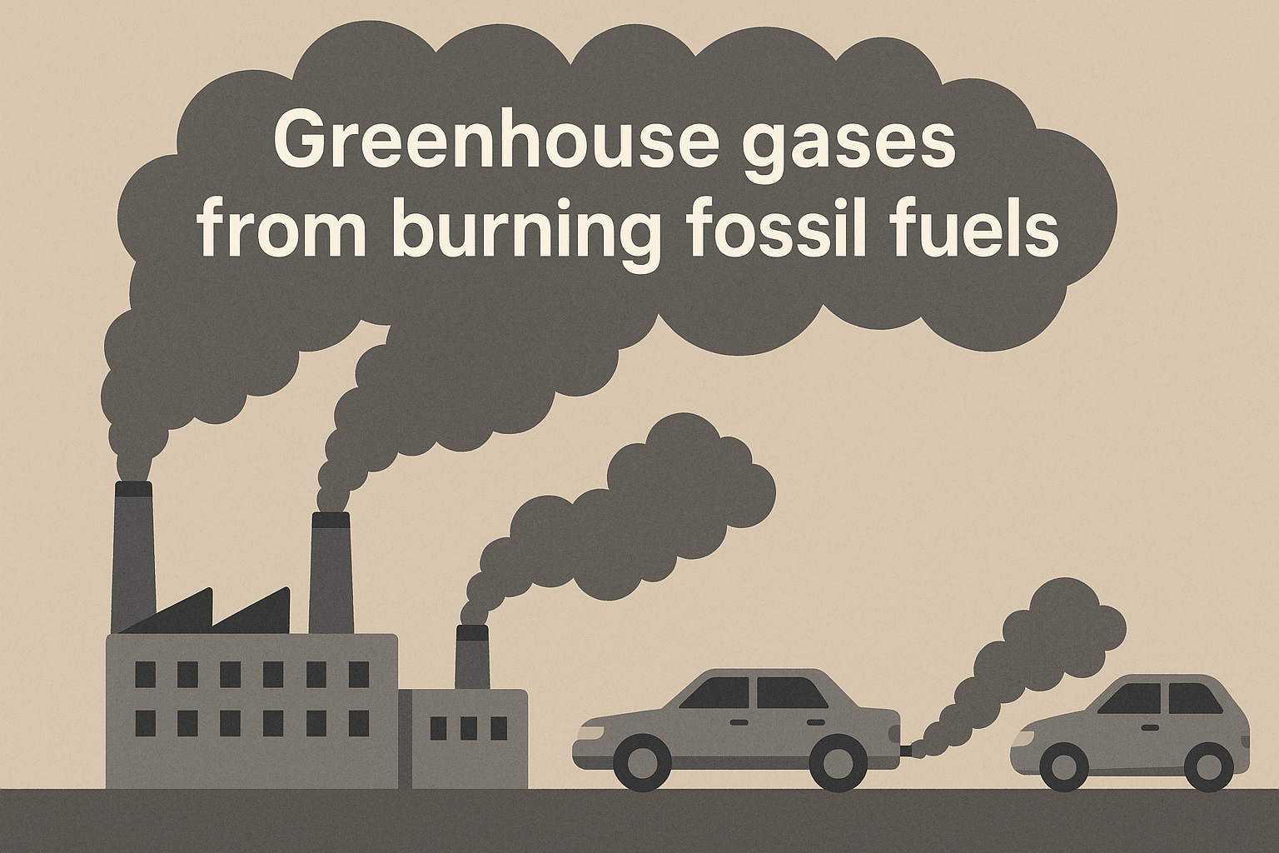

**[6-9s]**

* **Visual:** Atmospheric layer traps sun rays as heat around Earth.
* **Text:** "These gases trap heat"
* **Audio:** Narrator: "These gases trap heat, warming our planet."  
  **Image creation by sora:**

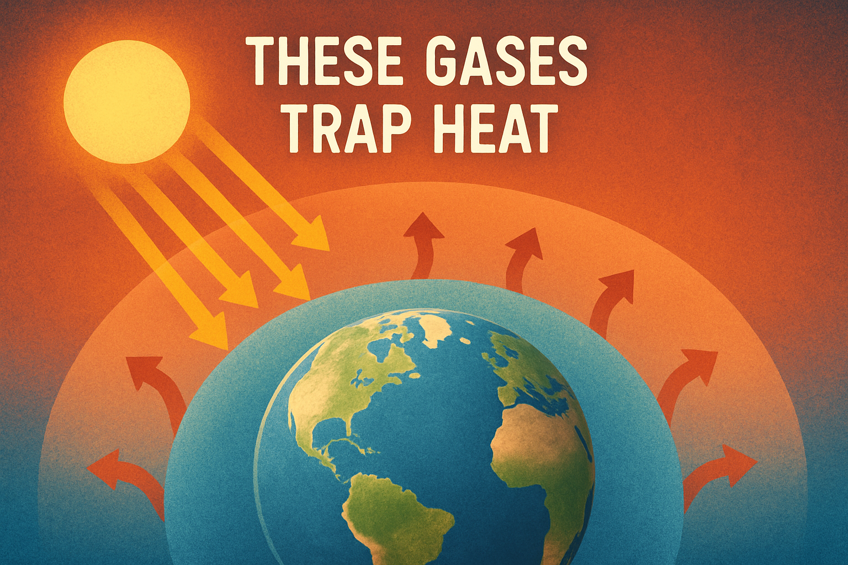

**[9-12s]**

* **Visual:** Quick transition between melting glaciers, raging wildfires, and heavy flooding.
* **Text:** "Extreme weather"
* **Audio:** Narrator: "This causes melting glaciers and extreme weather."  
    
  **Image creation by sora: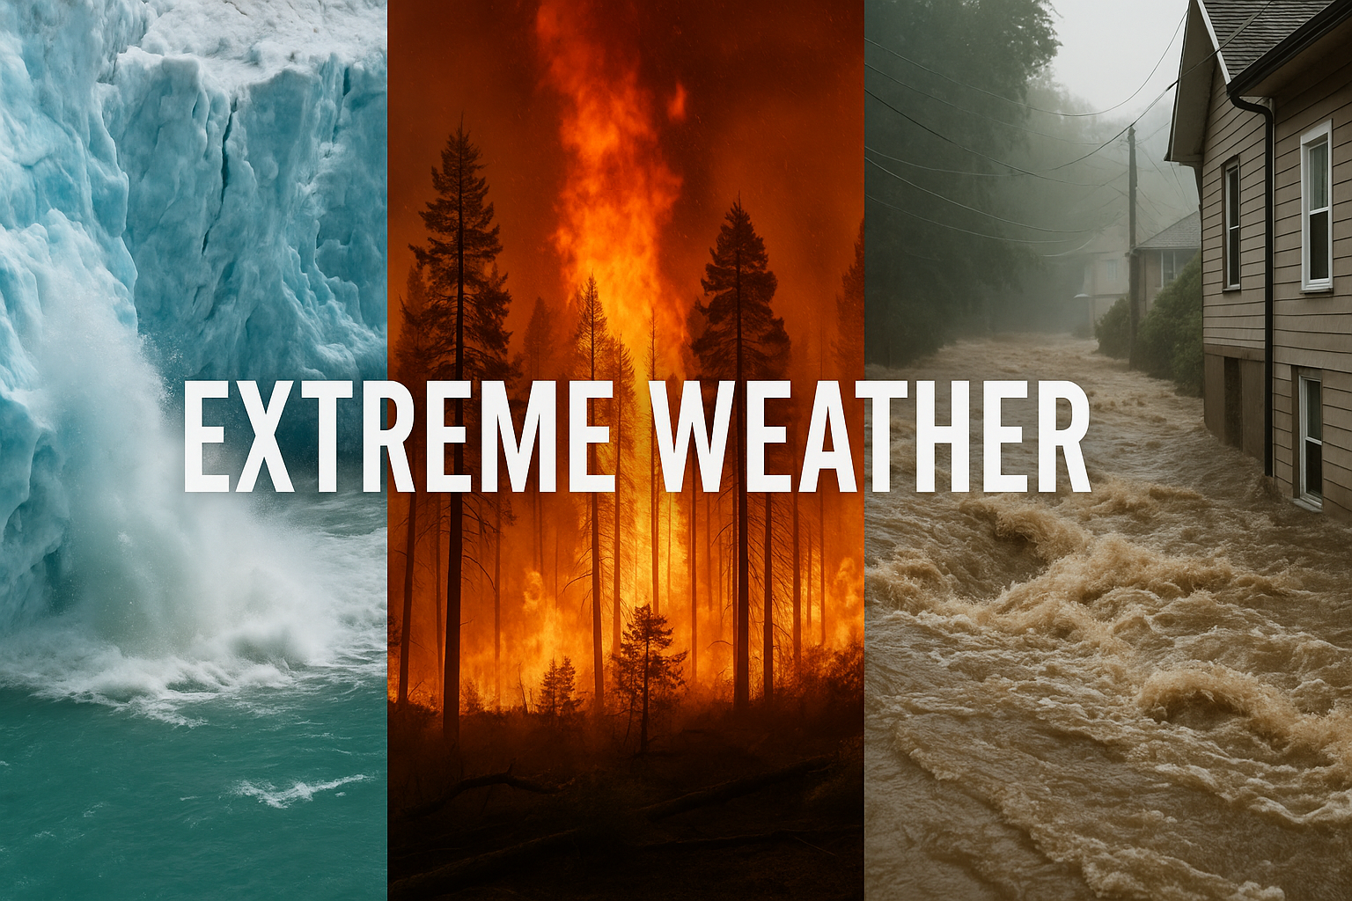:**

**[12-15s]**

* **Visual:** Diverse group of children plant a tree and ride bikes; sun appears bright and hopeful.
* **Text:** "You can help!"
* **Audio:** Narrator: "Together, we can fight climate change!"

**Image creation by sora:**